**Field Performance Testing**

**T-Mobile Pilot 5G Wi-Fi Calling Performance**

**Keysight Solution**

|  |  |
| --- | --- |
| **Customer Name** | T-Mobile |
| **Device** | Samsung A16 |
| **Hardware** | 1.0 |
| **Test Dates** |  |
| **Report Date** | 10/15/2024 |
| **Version** | 1 |

Report Revisions

|  |  |  |  |
| --- | --- | --- | --- |
| Revised on | Version | Description | Author |
| 10/15/2024 | 1 | Initial Document Creation | Raj Dinesh Kapadia |

Table of Contents

Test Methodology 1

Test Device Information 2

[A.1] 9.1.1 WFC Call Performance Overall Summary 4](#_Toc159433438)

[A.2] WFC Call Performance Results Summary 5](#_Toc159433439)

[B.1] WFC Call Performance 7](#_Toc159433440)

B.1.1 Linksys Hydra - WFC Call Performance 7

B.1.2 Asus - WFC Call Performance 8

B.1.3 Google Nest - WFC Call Performance 9

[C.1] WFC Handovers Overall Summary 10](#_Toc159433444)

[C.2] WFC Handover Results Summary 11](#_Toc159433445)

[D.1] WFC Handover 13](#_Toc159433446)

D.1.1 Linksys - WFC Handovers 13

D.1.2 Asus - WFC Handovers 14

D.1.3 Nokia -- WFC Handovers 15

[E.1] WFC Handovers (IP Impairment) Overall Summary 16](#_Toc159433450)

[E.2] WFC Handover (IP Impairment) Results Summary 17](#_Toc159433451)

[F.1] WFC Handovers (IP Impairment) 19](#_Toc159433452)

F.1.1 Linksys – WFC Handovers (IP Impairment) 19

F.1.2 Asus – WFC Handovers (IP Impairment) 20

F.1.3 Google Nest – WFC Handovers (IP Impairment) 21

[G.1] Rove-Out and Rove-In Overall Summary 22](#_Toc159433456)

[G.2] Rove-Out and Rove-In Results Summary 23](#_Toc159433457)

[H.1] Rove-Out and Rove-In 25](#_Toc159433458)

H.1.1 Linksys – Rove-Out and Rove-In 25

H.1.2 Asus – Rove-Out and Rove-In 26

H.1.3 Nokia – Rove-Out and Rove-In 27

# Test Methodology

|  |  |
| --- | --- |
| **Test Name** | WFC PERFORMANCE |
| **Wi-Fi Access Points** | Call and Audio Performance  • Google Nest Wi-Fi AP AC2200  • ASUS RT-AC68U  • Linksys Hydra Pro 6E    Multi-Handovers  • Nokia 5G21-12W-A Gateway  • ASUS RT-AC68U  • Linksys Hydra Pro 6E    Rove in/Rove out  • Nokia 5G21-12W-A Gateway  • ASUS RT-AC68U  • Linksys Hydra Pro 6E    WFC IP impairment test  • Google Nest Wi-Fi AP AC2200  • ASUS RT-AC68U  • Linksys Hydra Pro 6E |
| **Guidelines** | Test Setup   * Device under test (DUT) needs to be in a chamber with RF radiated. * Device under test (DUT) should be mounted on a Turn table. * WiFi connectivity and Access Point should be connected to internet and signal needs to be fed inside the Chamber. * T-Mobile Production signal should be piped inside the Chamber. * Access point RF signal and T-Mobile Production signal needs to be attenuated inside the chamber. * MOS measurement tool must be used to measure Audio Quality. MOS must be extracted before and after the Handover completion. MoS needs to measure between Handover command message and Handover complete message. * Network emulator should be connected to introduce IP impairments. * Network emulator should be connected to introduce loading * Network emulator must support scenario captured from the Field and played inside the lab. Typical garage scenario needs to be captured where User leave the house from the Garage. |
| **Devices Tested** | * 2 devices total for all test cases. 1 DUT and 1 REF. |
| **Key Performance Indicators** | * Call Setup time * MO Success rate * MT Success rate * Call Retention * Packet Loss * Handovers * Call Attempts |

Test Methodology and Execution based on Element T-Mobile Field Test Plan v1.6 and Operational Plan v1.0

# Test Device Information

|  |  |  |  |
| --- | --- | --- | --- |
|  | Test Device:  Reference: | TCL Goldfinch  Samsung S23 |  |

|  |  |  |  |  |
| --- | --- | --- | --- | --- |
| **Device Label** | **Test Role** | **Software Version** | **Hardware Version** | **IMEI** |
| Samsung A16 | Test Device | VVK35.54 | 1.0 | 352291420059098 |
| TCL Goldfinch | Reference | 5EAY | 1.0 | 016519000009945 |

Baseline Wi-Fi Calling

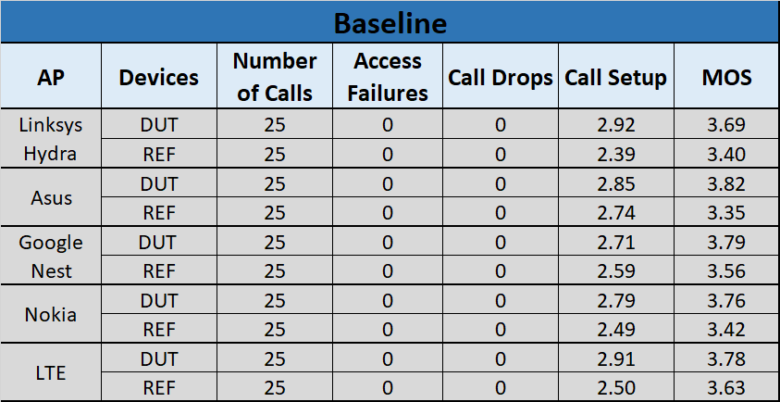

A.1] 9.1.1 WFC Call Performance Overall Summary

Overall KPIs for all Wi-Fi APs across all Test Environments

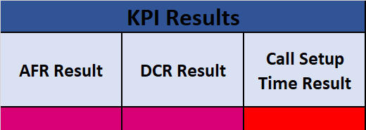

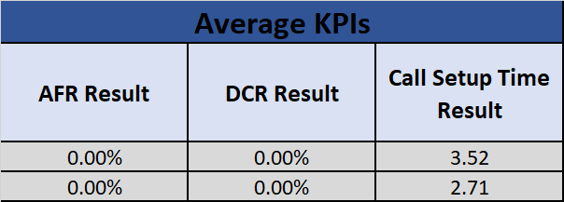

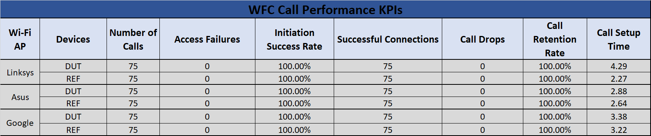

## A.2] WFC Call Performance Results Summary

|  |  |  |  |
| --- | --- | --- | --- |
| **Wi-Fi AP** |  | **Test** | **Results** |
| **Linksys Hydra** | ETSI-B | Call Initiation |  |
| Call Retention |  |
| Call Setup Time |  |
| MOS |  |
| NSD-A | Call Initiation |  |
| Call Retention |  |
| Call Setup Time |  |
| MOS |  |
| NSD-C | Call Initiation |  |
| Call Retention |  |
| Call Setup Time |  |
| MOS |  |
| **ASUS** | ETSI-B | Call Initiation |  |
| Call Retention |  |
| Call Setup Time |  |
| MOS |  |
| NSD-A | Call Initiation |  |
| Call Retention |  |
| Call Setup Time |  |
| MOS |  |
| NSD-C | Call Initiation |  |
| Call Retention |  |
| Call Setup Time |  |
| MOS |  |
| **Google Nest** | ETSI-B | Call Initiation |  |
| Call Retention |  |
| Call Setup Time |  |
| MOS |  |
| NSD-A | Call Initiation |  |
| Call Retention |  |
| Call Setup Time |  |
| MOS |  |
| NSD-C | Call Initiation |  |
| Call Retention |  |
| Call Setup Time |  |
| MOS |  |

**Call Performance Pass/Fail Criteria**

|  |  |
| --- | --- |
|  | **Outperformed REF** |
|  | **Passing** |
|  | **Marginal** |
|  | **Fail** |

|  |  |
| --- | --- |
| **Parameter** | **Pass/Fail Criteria** |
| **Mobile Originating Success** | If p-value for Fisher Exact > 0.99 for the MO failures of DUT vs REF |
| If p-value for Fisher Exact is between 0.05 and 0.99 for the MO failures of DUT vs REF ) |
| If RED condition is satisfied but % MO Failures (DUT) < 1% |
| If p-value for Fisher Exact < 0.05 for the MO failures of DUT vs REF |
|  | |
| **Mobile Terminating Success** | If p-value for Fisher Exact > 0.99 for the MT failures of DUT vs REF |
| If p-value for Fisher Exact is between 0.05 and 0.99 for the MT failures of DUT vs REF |
| If RED condition is satisfied but % MT Failures (DUT) < 1% |
| If p-value for Fisher Exact < 0.05 for the MT failures of DUT vs REF |
|  | |
| **Call Retention** | If p-value for Fisher Exact > 0.99 for the Dropped Calls of DUT vs REF |
| If p-value for Fisher Exact is between 0.05 and 0.99 for the Dropped calls of DUT vs REF |
| If RED condition is satisfied but % Dropped calls (DUT) < 1% |
| If p-value for Fisher Exact < 0.05 for the Dropped calls of DUT vs REF |
|  | |
| **MO Call Setup Time** | If (Avg MO call setup time of Two DUT's is better than Avg MO call setup time of Two REFs by 10%) |
| If (Avg MO call setup time of Two DUT's is < 10% of Avg MO call setup time of Two REF's ) |
| If (Avg MO call setup time of Two DUT's is < 20% of Avg MO call setup time of Two REF's ) |
| If (Avg MO call setup time of Two DUT's is worst by 20% of Avg MO Call setup time of TWO Ref's |
|  | |
| **MT Call Setup Time** | If (Avg MT call setup time of Two DUT's is better than Avg MT call setup time of Two REF's by 10%) |
| If (Avg MT call setup time of Two DUT's is < 10% of Avg MT call setup time of Two REF's ) |
| If (Avg MT call setup time of Two DUT's is < 20% of Avg MT call setup time of Two REF's ) |
| If (Avg MT call setup time of Two DUT's is worst by 20% of Avg MT Call setup time of TWO Ref's |
|  | |
| **MOS** | If (Average MOS Worst DUT) > (Average MOS REF) in all markets |
| If (Average MOS Worst DUT) > (Average MOS REF – 0.1) |
| If Green or Red not satisfied |
| If (Average MOS Worst DUT) < (Average MOS REF – 0.25) in any one market |

## B.1] WFC Call Performance

### B.1.1 Linksys Hydra - WFC Call Performance

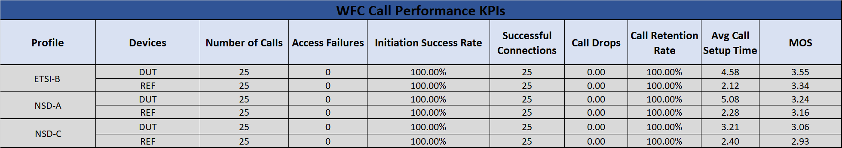

### B.1.2 Asus - WFC Call Performance

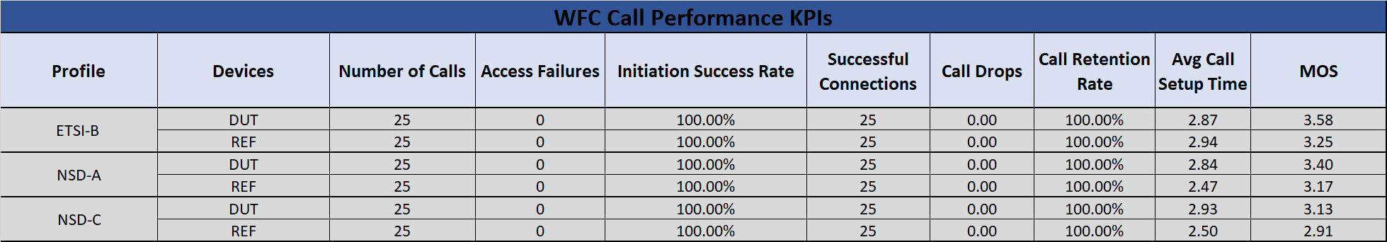

### B.1.3 Google Nest - WFC Call Performance

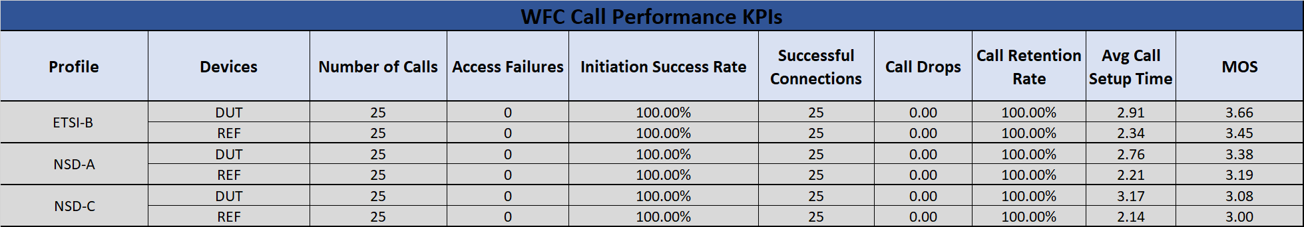

C.1] WFC Handovers Overall Summary

Overall drop call rate and access failure rate for all Wi-Fi APs across all Test Environments

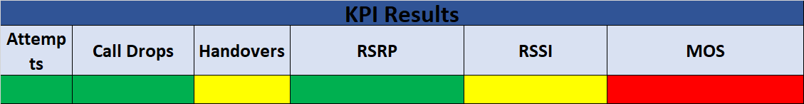

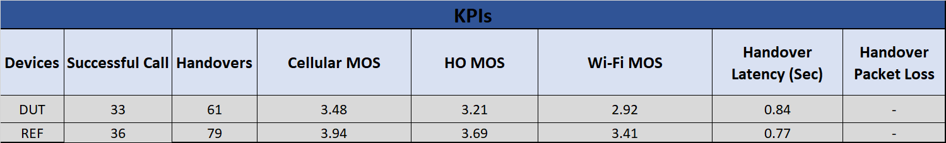

## C.2] WFC Handover Results Summary

|  |  |  |  |
| --- | --- | --- | --- |
| **Wi-Fi AP** |  | **Test** | **Results** |
| **Linksys Hydra** | Profile 1 | Call Attempts |  |
| Call Drops |  |
| Handover |  |
| RSRP |  |
| RSSI |  |
| MOS |  |
| Profile 2 | Call Attempts |  |
| Call Drops |  |
| Handover |  |
| RSRP |  |
| RSSI |  |
| MOS |  |
| Profile 3 | Call Attempts |  |
| Call Drops |  |
| Handover |  |
| RSRP |  |
| RSSI |  |
| MOS |  |
| **ASUS** | Profile 1 | Call Attempts |  |
| Call Drops |  |
| Handover |  |
| RSRP |  |
| RSSI |  |
| MOS |  |
| Profile 2 | Call Attempts |  |
| Call Drops |  |
| Handover |  |
| RSRP |  |
| RSSI |  |
| MOS |  |
| Profile 3 | Call Attempts |  |
| Call Drops |  |
| Handover |  |
| RSRP |  |
| RSSI |  |
| MOS |  |
| Nokia | Profile 1 | Call Attempts |  |
| Call Drops |  |
| Handover |  |
| RSRP |  |
| RSSI |  |
| MOS |  |
| Profile 2 | Call Attempts |  |
| Call Drops |  |
| Handover |  |
| RSRP |  |
| RSSI |  |
| MOS |  |
| Profile 3 | Call Attempts |  |
| Call Drops |  |
| Handover |  |
| RSRP |  |
| RSSI |  |
| MOS |  |

**Call Performance Pass/Fail Criteria**

|  |  |
| --- | --- |
|  | **Outperformed REF** |
|  | **Passing** |
|  | **Marginal** |
|  | **Fail** |

|  |  |
| --- | --- |
| **Parameter** | **Pass/Fail Criteria** |
| **Mobile Originating Success** | If p-value for Fisher Exact > 0.99 for the MO failures of DUT vs REF |
| If p-value for Fisher Exact is between 0.05 and 0.99 for the MO failures of DUT vs REF ) |
| If RED condition is satisfied but % MO Failures (DUT) < 1% |
| If p-value for Fisher Exact < 0.05 for the MO failures of DUT vs REF |
|  | |
| **Mobile Terminating Success** | If p-value for Fisher Exact > 0.99 for the MT failures of DUT vs REF |
| If p-value for Fisher Exact is between 0.05 and 0.99 for the MT failures of DUT vs REF |
| If RED condition is satisfied but % MT Failures (DUT) < 1% |
| If p-value for Fisher Exact < 0.05 for the MT failures of DUT vs REF |
|  | |
| **Call Retention** | If p-value for Fisher Exact > 0.99 for the Dropped Calls of DUT vs REF |
| If p-value for Fisher Exact is between 0.05 and 0.99 for the Dropped calls of DUT vs REF |
| If RED condition is satisfied but % Dropped calls (DUT) < 1% |
| If p-value for Fisher Exact < 0.05 for the Dropped calls of DUT vs REF |
|  | |
| **MO Call Setup Time** | If (Avg MO call setup time of Two DUT's is better than Avg MO call setup time of Two REFs by 10%) |
| If (Avg MO call setup time of Two DUT's is < 10% of Avg MO call setup time of Two REF's ) |
| If (Avg MO call setup time of Two DUT's is < 20% of Avg MO call setup time of Two REF's ) |
| If (Avg MO call setup time of Two DUT's is worst by 20% of Avg MO Call setup time of TWO Ref's |
|  | |
| **MT Call Setup Time** | If (Avg MT call setup time of Two DUT's is better than Avg MT call setup time of Two REF's by 10%) |
| If (Avg MT call setup time of Two DUT's is < 10% of Avg MT call setup time of Two REF's ) |
| If (Avg MT call setup time of Two DUT's is < 20% of Avg MT call setup time of Two REF's ) |
| If (Avg MT call setup time of Two DUT's is worst by 20% of Avg MT Call setup time of TWO Ref's |
|  | |
| **MOS** | If (Average MOS Worst DUT) > (Average MOS REF) in all markets |
| If (Average MOS Worst DUT) > (Average MOS REF – 0.1) |
| If Green or Red not satisfied |
| If (Average MOS Worst DUT) < (Average MOS REF – 0.25) in any one market |

## D.1] WFC Handover

### D.1.1 Linksys - WFC Handovers

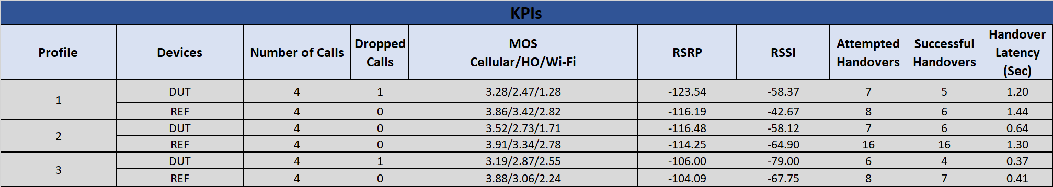

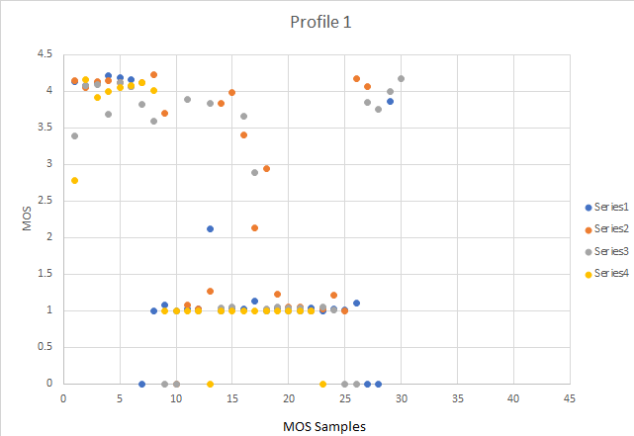

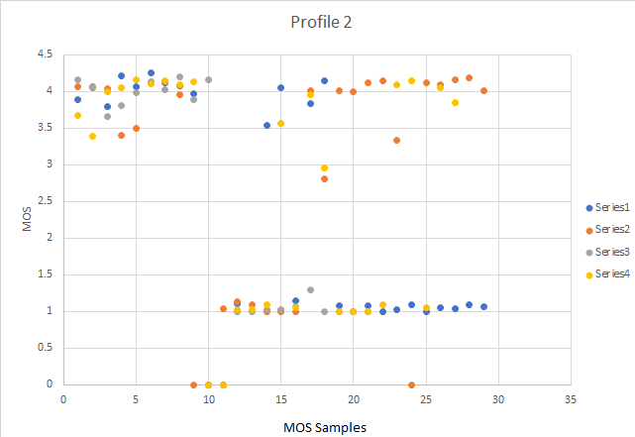

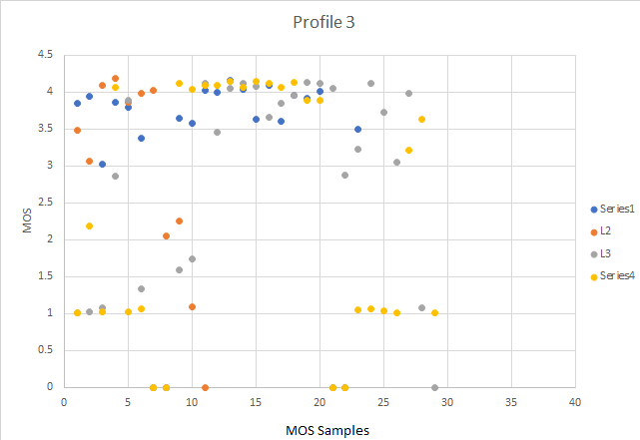

### D.1.2 Asus - WFC Handovers

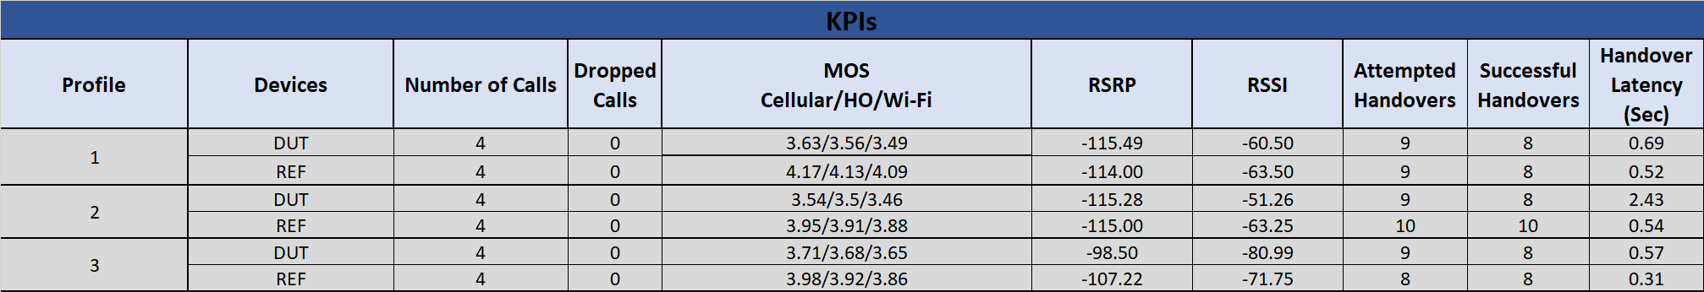

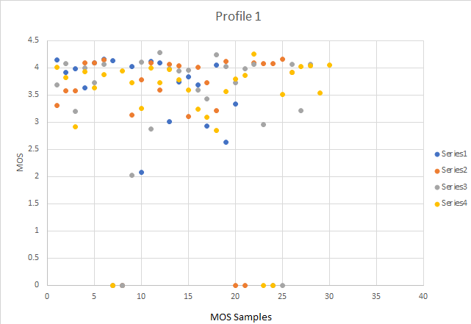

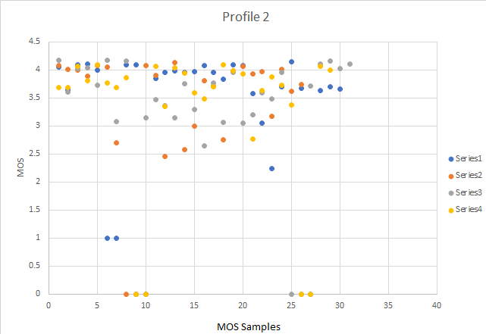

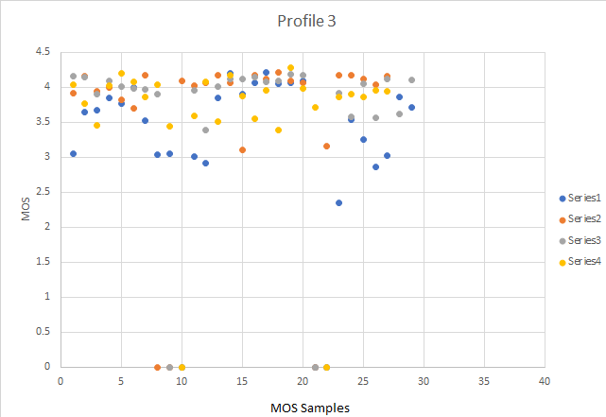

### D.1.3 Nokia - WFC Handovers

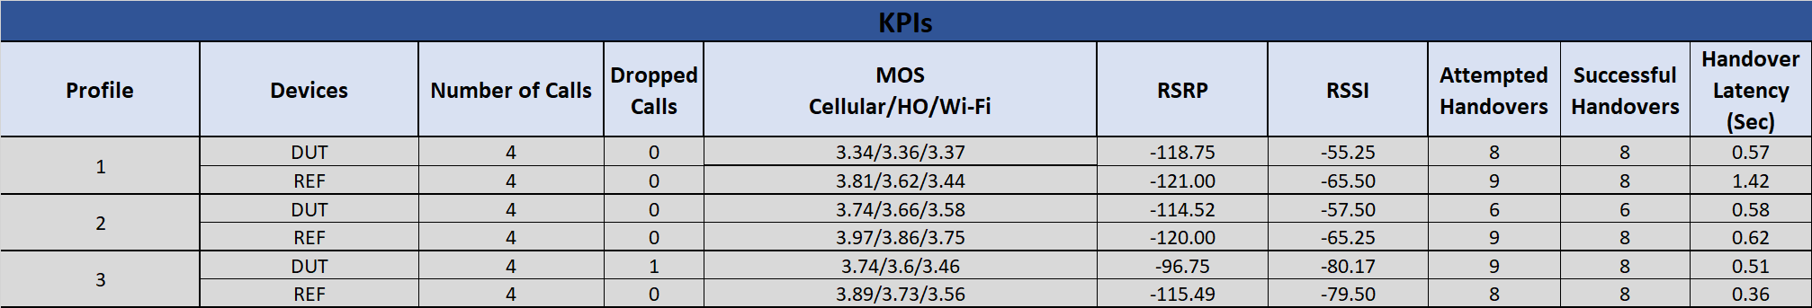

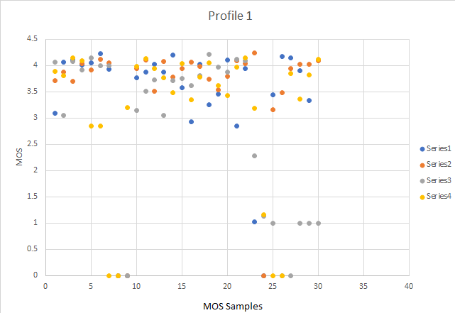

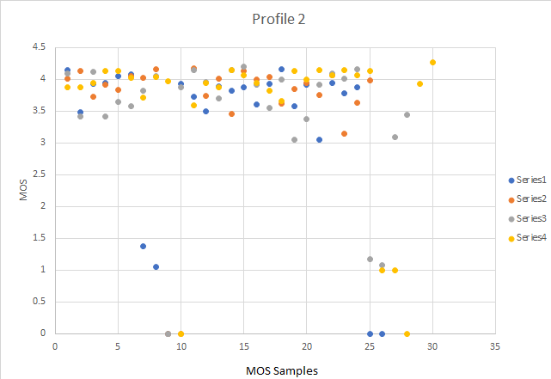

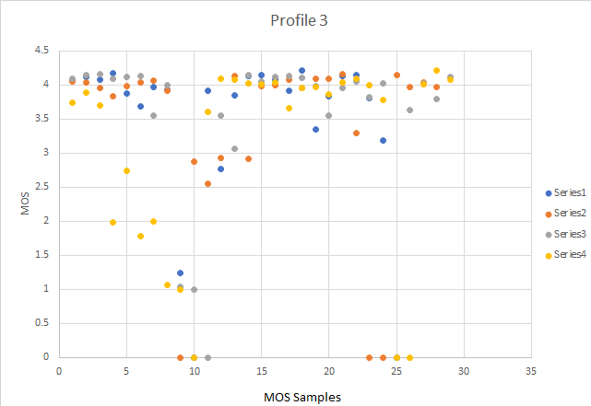

E.1] WFC Handovers (IP Impairment) Overall Summary

Overall KPIs for all Wi-Fi APs across all Test Environments

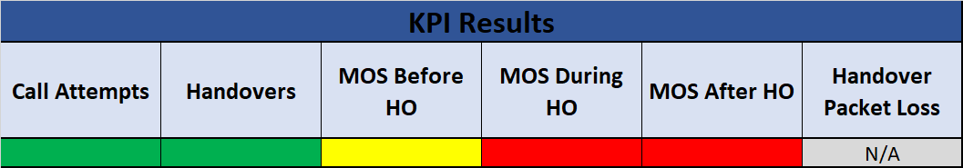

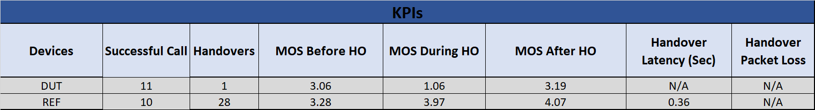

## E.2] WFC Handover (IP Impairment) Results Summary

|  |  |  |  |
| --- | --- | --- | --- |
| **Wi-Fi AP** |  | **Test** | **Results** |
| **Linksys Hydra** | Profile 4 | Call Attempts |  |
| Call Drops |  |
| Handover occurred |  |
| MOS Before Handover |  |
| MOS During and After Handover |  |
| Handover delay impact to speech |  |
| Packet Loss |  |
| **ASUS** | Profile 4 | Call Attempts |  |
| Call Drops |  |
| Handover occurred |  |
| MOS Before Handover |  |
| MOS During and After Handover |  |
| Handover delay impact to speech |  |
| Packet Loss |  |
| **Google Nest** | Profile 4 | Call Attempts |  |
| Call Drops |  |
| Handover occurred |  |
| MOS Before Handover |  |
| MOS During and After Handover |  |
| Handover delay impact to speech |  |
| Packet Loss |  |

**Call Performance Pass/Fail Criteria**

|  |  |
| --- | --- |
|  | **Outperformed REF** |
|  | **Passing** |
|  | **Marginal** |
|  | **Fail** |

|  |  |
| --- | --- |
| **Parameter** | **Pass/Fail Criteria** |
| **Mobile Originating Success** | If p-value for Fisher Exact > 0.99 for the MO failures of DUT vs REF |
| If p-value for Fisher Exact is between 0.05 and 0.99 for the MO failures of DUT vs REF ) |
| If RED condition is satisfied but % MO Failures (DUT) < 1% |
| If p-value for Fisher Exact < 0.05 for the MO failures of DUT vs REF |
|  | |
| **Mobile Terminating Success** | If p-value for Fisher Exact > 0.99 for the MT failures of DUT vs REF |
| If p-value for Fisher Exact is between 0.05 and 0.99 for the MT failures of DUT vs REF |
| If RED condition is satisfied but % MT Failures (DUT) < 1% |
| If p-value for Fisher Exact < 0.05 for the MT failures of DUT vs REF |
|  | |
| **Call Retention** | If p-value for Fisher Exact > 0.99 for the Dropped Calls of DUT vs REF |
| If p-value for Fisher Exact is between 0.05 and 0.99 for the Dropped calls of DUT vs REF |
| If RED condition is satisfied but % Dropped calls (DUT) < 1% |
| If p-value for Fisher Exact < 0.05 for the Dropped calls of DUT vs REF |
|  | |
| **MO Call Setup Time** | If (Avg MO call setup time of Two DUT's is better than Avg MO call setup time of Two REFs by 10%) |
| If (Avg MO call setup time of Two DUT's is < 10% of Avg MO call setup time of Two REF's ) |
| If (Avg MO call setup time of Two DUT's is < 20% of Avg MO call setup time of Two REF's ) |
| If (Avg MO call setup time of Two DUT's is worst by 20% of Avg MO Call setup time of TWO Ref's |
|  | |
| **MT Call Setup Time** | If (Avg MT call setup time of Two DUT's is better than Avg MT call setup time of Two REF's by 10%) |
| If (Avg MT call setup time of Two DUT's is < 10% of Avg MT call setup time of Two REF's ) |
| If (Avg MT call setup time of Two DUT's is < 20% of Avg MT call setup time of Two REF's ) |
| If (Avg MT call setup time of Two DUT's is worst by 20% of Avg MT Call setup time of TWO Ref's |
|  | |
| **MOS** | If (Average MOS Worst DUT) > (Average MOS REF) in all markets |
| If (Average MOS Worst DUT) > (Average MOS REF – 0.1) |
| If Green or Red not satisfied |
| If (Average MOS Worst DUT) < (Average MOS REF – 0.25) in any one market |

## F.1] WFC Handovers (IP Impairment)

### F.1.1 Linksys – WFC Handovers (IP Impairment)



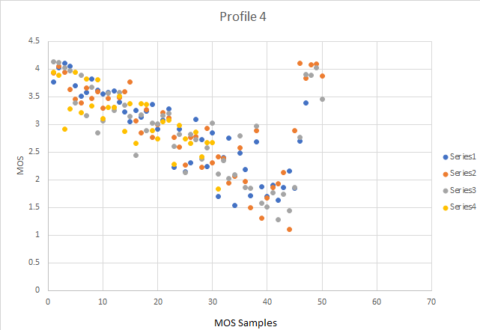

### F.1.2 Asus – WFC Handovers (IP Impairment)



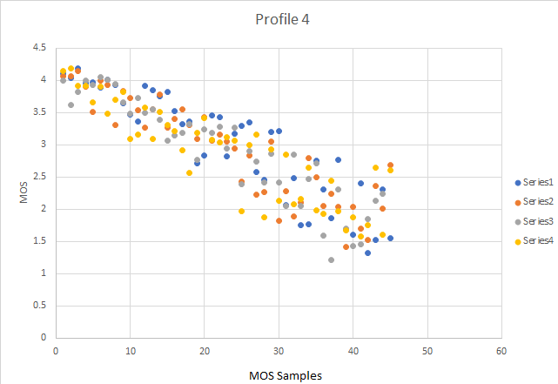

### F.1.3 Google Nest – WFC Handovers (IP Impairment)



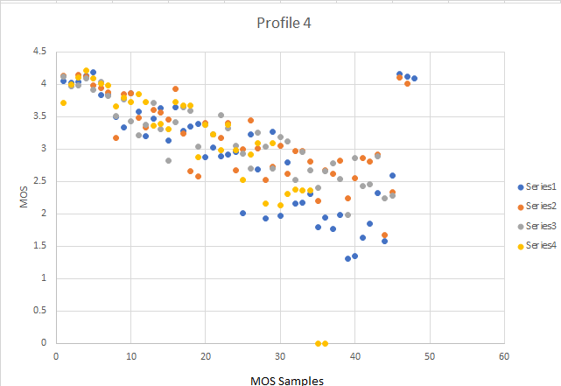

## G.1] Rove-Out and Rove-In Overall Summary

Overall KPIs for all Wi-Fi APs across all Test Environments

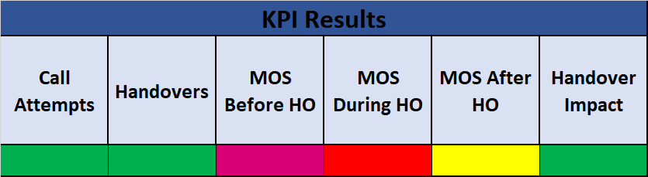

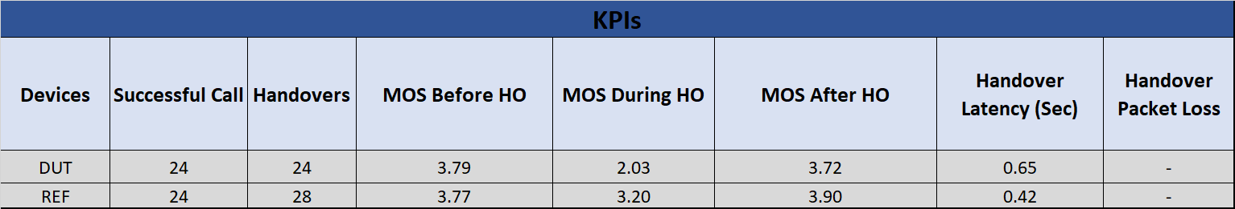

## G.2] Rove-Out and Rove-In Results Summary

|  |  |  |  |
| --- | --- | --- | --- |
| **Wi-Fi AP** |  | **Test** | **Results** |
| **Linksys Hydra** | Profile 5 | Call Attempts |  |
| Call Drop |  |
| RSSI |  |
| RSRP |  |
| MOS Before Handover |  |
| MOS during and after Handover |  |
| Handover occurred |  |
| Handover Delay impact to Speech |  |
| Profile 6 | Call Attempts |  |
| Call Drop |  |
| RSSI |  |
| RSRP |  |
| MOS Before Handover |  |
| MOS during and after Handover |  |
| Handover occurred |  |
| Handover Delay impact to Speech |  |
| **ASUS** | Profile 5 | Call Attempts |  |
| Call Drop |  |
| RSSI |  |
| RSRP |  |
| MOS Before Handover |  |
| MOS during and after Handover |  |
| Handover occurred |  |
| Handover Delay impact to Speech |  |
| Profile 6 | Call Attempts |  |
| Call Drop |  |
| RSSI |  |
| RSRP |  |
| MOS Before Handover |  |
| MOS during and after Handover |  |
| Handover occurred |  |
| Handover Delay impact to Speech |  |
| **Nokia** | Profile 5 | Call Attempts |  |
| Call Drop |  |
| RSSI |  |
| RSRP |  |
| MOS Before Handover |  |
| MOS during and after Handover |  |
| Handover occurred |  |
| Handover Delay impact to Speech |  |
| Profile 6 | Call Attempts |  |
| Call Drop |  |
| RSSI |  |
| RSRP |  |
| MOS Before Handover |  |
| MOS during and after Handover |  |
| Handover occurred |  |
| Handover Delay impact to Speech |  |

**Call Performance Pass/Fail Criteria**

|  |  |
| --- | --- |
|  | **Outperformed REF** |
|  | **Passing** |
|  | **Marginal** |
|  | **Fail** |

|  |  |
| --- | --- |
| **Parameter** | **Pass/Fail Criteria** |
| **Mobile Originating Success** | If p-value for Fisher Exact > 0.99 for the MO failures of DUT vs REF |
| If p-value for Fisher Exact is between 0.05 and 0.99 for the MO failures of DUT vs REF ) |
| If RED condition is satisfied but % MO Failures (DUT) < 1% |
| If p-value for Fisher Exact < 0.05 for the MO failures of DUT vs REF |
|  | |
| **Mobile Terminating Success** | If p-value for Fisher Exact > 0.99 for the MT failures of DUT vs REF |
| If p-value for Fisher Exact is between 0.05 and 0.99 for the MT failures of DUT vs REF |
| If RED condition is satisfied but % MT Failures (DUT) < 1% |
| If p-value for Fisher Exact < 0.05 for the MT failures of DUT vs REF |
|  | |
| **Call Retention** | If p-value for Fisher Exact > 0.99 for the Dropped Calls of DUT vs REF |
| If p-value for Fisher Exact is between 0.05 and 0.99 for the Dropped calls of DUT vs REF |
| If RED condition is satisfied but % Dropped calls (DUT) < 1% |
| If p-value for Fisher Exact < 0.05 for the Dropped calls of DUT vs REF |
|  | |
| **MO Call Setup Time** | If (Avg MO call setup time of Two DUT's is better than Avg MO call setup time of Two REFs by 10%) |
| If (Avg MO call setup time of Two DUT's is < 10% of Avg MO call setup time of Two REF's ) |
| If (Avg MO call setup time of Two DUT's is < 20% of Avg MO call setup time of Two REF's ) |
| If (Avg MO call setup time of Two DUT's is worst by 20% of Avg MO Call setup time of TWO Ref's |
|  | |
| **MT Call Setup Time** | If (Avg MT call setup time of Two DUT's is better than Avg MT call setup time of Two REF's by 10%) |
| If (Avg MT call setup time of Two DUT's is < 10% of Avg MT call setup time of Two REF's ) |
| If (Avg MT call setup time of Two DUT's is < 20% of Avg MT call setup time of Two REF's ) |
| If (Avg MT call setup time of Two DUT's is worst by 20% of Avg MT Call setup time of TWO Ref's |
|  | |
| **MOS** | If (Average MOS Worst DUT) > (Average MOS REF) in all markets |
| If (Average MOS Worst DUT) > (Average MOS REF – 0.1) |
| If Green or Red not satisfied |
| If (Average MOS Worst DUT) < (Average MOS REF – 0.25) in any one market |

## H.1] Rove-Out and Rove-In

### H.1.1 Linksys – Rove-Out and Rove-In

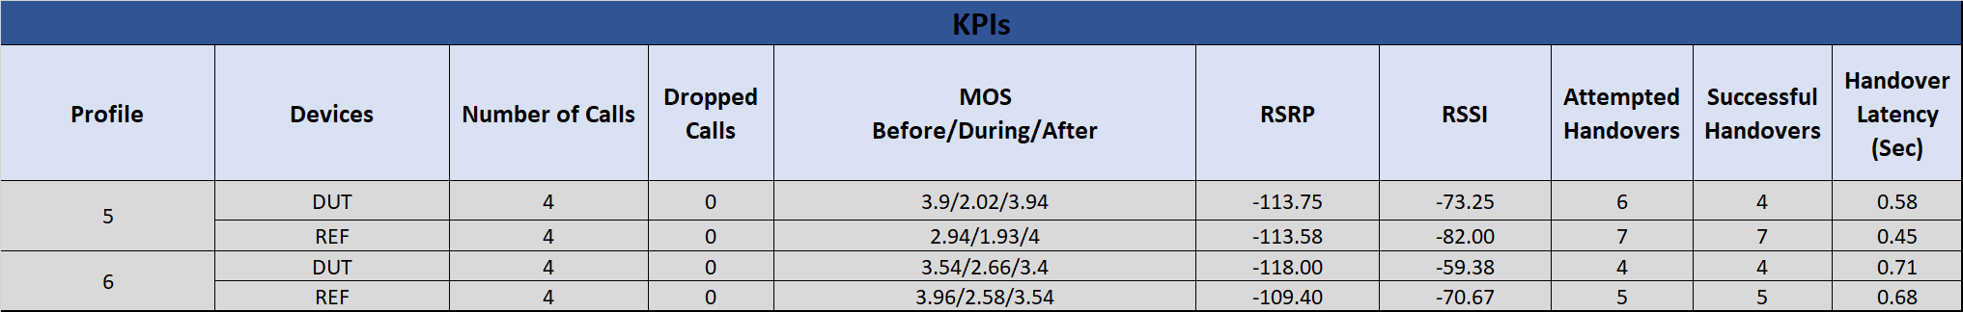

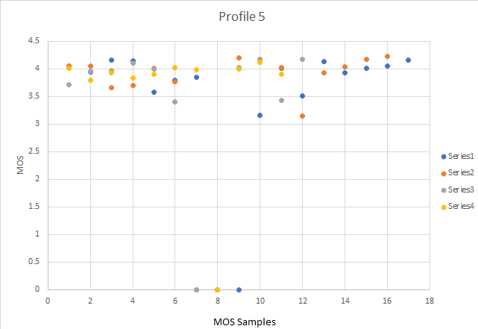

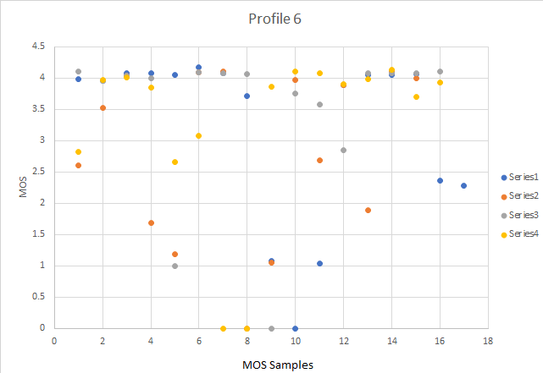

### H.1.2 Asus – Rove-Out and Rove-In

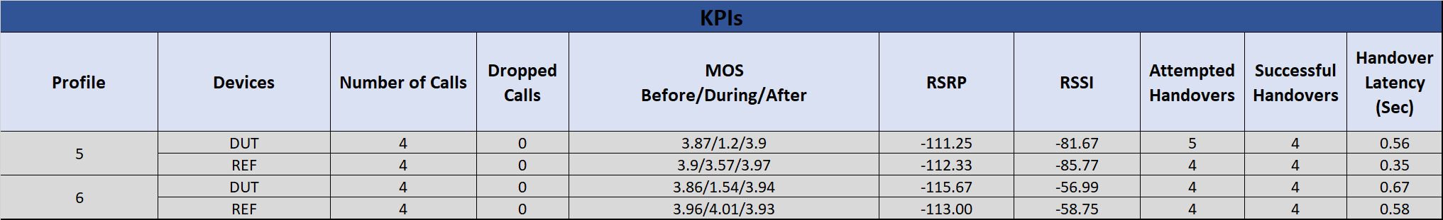

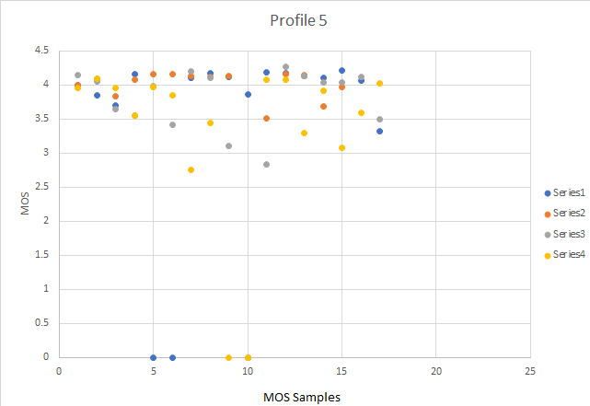

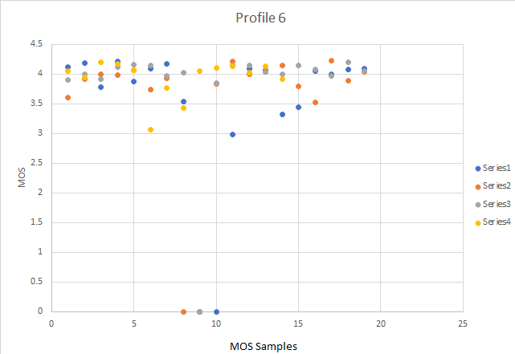

### H.1.3 Nokia – Rove-Out and Rove-In

